The Analysis of Putting Game for Players of Different Ability

(IEE 572 Project)

December 4, 2000

J. E. Park 992-98-4351

D. Alvarez 601-62-3670

S. G. Kang 993-26-2754

The Analysis of Putting Game for Players of Different Ability

J.E. Park, S.G. Kang and D. Alvarez
Dept. of Electrical Engineering
Arizona State University
Tempe, AZ 85287-5706

Abstract
Putting seems to be a simple game; it is just rolling the round ball into a round cup sitting on the green. However, it can be considered one of the most worrisome problems for golfers. The improvement of the putting game is as important as the long drive or the accuracy of iron shots. We tried to find the common factors that affect golfers of different ability in order to understand putting better. The test was carried out on three players of different levels of ability using two different putters, balls and putting from two different points. Response variable was the distance of ball from the hole after putting. This test was performed on the Rye grass at ASU Karsten course. After the analysis of 8 replicated 2³ factorial tests, we obtained detailed analysis results from the experiments, which can be educational for players. As a common important factor for mid and low handicap, the green reading skill turned out to be important from this experiments.

Introduction
The end of every hole and golf game lies on the putting green. The most important moment for every golfer, whether he is looking for a big payday or trying not to lose beer money to fellow players, takes place on the putting green. On the green, all the glory of success or the pain of three-putting totally depends on the putting game as well as some luck too. One who is not lucky can easily blame his or her instrument as a mind-soothing excuse. “Should I have to buy this new putter? I can’t make a good putt with my old blade anyway!” Too much confusion boggles his mind. Where is the truth then? Is there any extremely forgiving putter that works for any players?
As any person who dreamed about making a long and lucrative eight feet putt at 18’s hole on a Sunday afternoon, we felt a consistent wonder and made efforts to improve our skill. What is a significant factor that can make a difference in the game? How can we find these answers in a more scientific and objective way? We decided to do some experiments using the analysis of variance technique [1] to seek for those answers.

Experiment
The test was carried out on three different level players, which were a fresh beginner, 25 handicapper and 9 handicapper. Each player putted eight times on two different path points eight feet away from the hole in a randomized order.

Factors
Which factors can affect someone’s putting game? Finding out the answer should improve the putting game. Some factors may include internal problems for the player, the putting mechanics the player used and external instrumental problems such as the design of the putter and weather. It is quite difficult to find significantly influential factors. So we decided to choose three commonly acceptable three factors; putting paths, ball type and putter type.
One of our factors is the type of putter. There are many factors in the putter itself, but what makes the most difference for our experiment design is the surface condition of putter. Nowadays, many different putter surface conditions have been developed. For our experiment, we took two different putters, one has an inserted putter face and the other has a milled face as shown in Figure 1. The milled face putter was chosen as a high level (+) and the inserted one as a low level (-) of first factor.
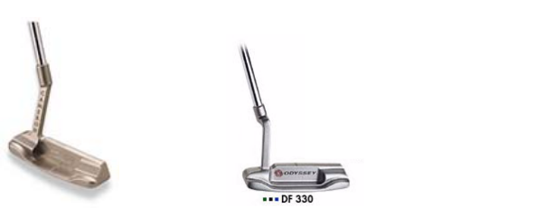

- Milled face (b) Inserted face

Figure 1. Two different putter types used in this experiment

Another factor is the type of ball, which is designed as factor B as shown in Figure 2. There are many small factors that can differentiate one from another such as the number of pieces of layers, liquid or solids core, and wound or non-wound. But for simplicity, two manufacturers of a ball were selected as our factor. Simply we noted “ball A” for high level and “ball B” for low level.



(a) Ball A (b) Ball B

Figure 2. Two different ball types for this experiment

Since a golfer faces many different types of putting surface, often inducing an unexpected surprise and forcing him or her to find some excuses for embarrassment, the putting path was chosen for a factor. It is closely related with each individual player’s green reading skill, too. Some players have a tendency to read break less than the real amount so their balls always miss the holes below, while others read too much so they miss above the hole. Yet, there can be many things that affect the reading ability and many conditions of green determine the breaks. In order to simplify the situation, the breaking and straight putting paths are chosen as the third factor as shown in Figure 3.
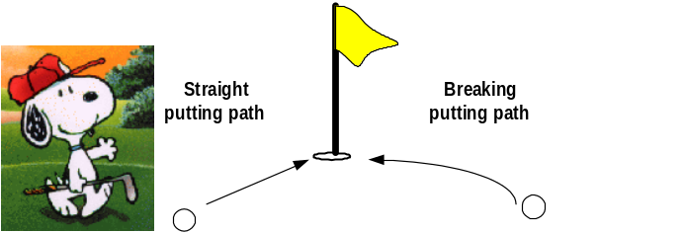
Figure 3. Two putting surface conditions

2³ factorial design with 8 replications
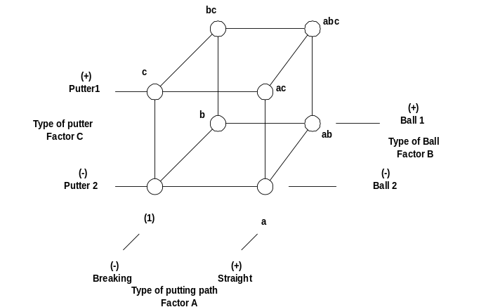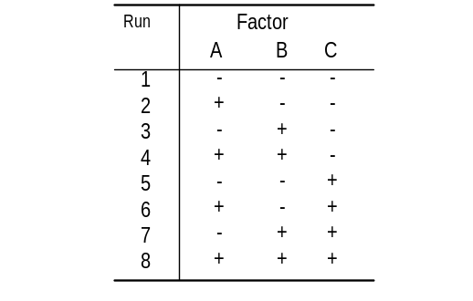 We plotted and conducted 2³ factorial design using the three factors as shown in Figure 4-(a). It is quite easy to understand this scheme for the problem and the design matrix is shown in Figure 4-(b).

(a) geometric view of the experiment (b) design matrix for 2³ factorial design
Figure 4. The geometric view and design matrix of the 2³ factorial design.

During the collection of data, each player made eight putts from eight feet away from the center of hole in randomized order. The response value was the distance from the hole.
The reason for choosing distance of eight feet was determined by D. Pelz’s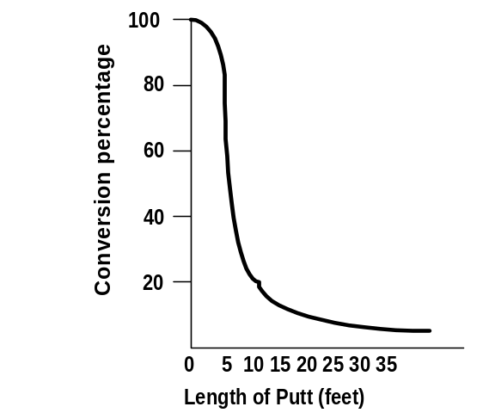 golden eight feet rule [2] as shown in Figure 5.

Figure 5. The conversion percentage with length of putts [2].

We can say that the distance of 8 feet corresponds to a transition distance between high and low conversion regimes. So, we can easily tell the effect of any factor at this distance.

We conducted three separate 2³ factorial design experiments of these three factors for three players.

Results
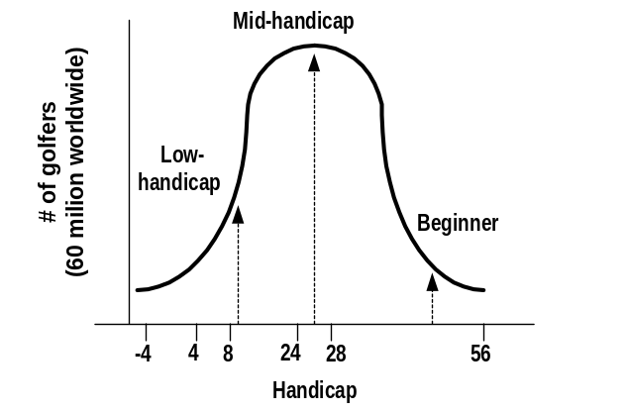After the analysis of variance, we collected data for design and analysis of experiment (DOE) and learned many detailed sides aspects of the game. Each player had individual problems but there were also common problems for all players. We chose three players to cover broadly the spectrum as shown in Figure 6.

Figure 6. The spectrum of golfer skills [2]

Beginner
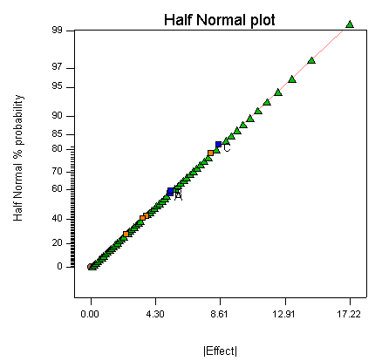
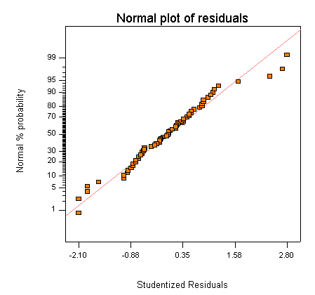
The beginner, who never played any golf before, took 20 min. of simple lessons for putting techniques and 10 min. warming-up practice. We couldn’t find any particular factor that affected his game as shown in Figure 7.

Figure 7. The half normal plot and the normal probability plot for the beginner’s experiment.
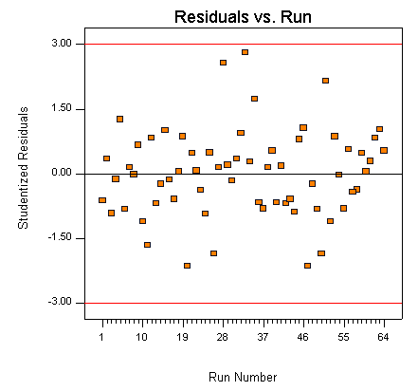
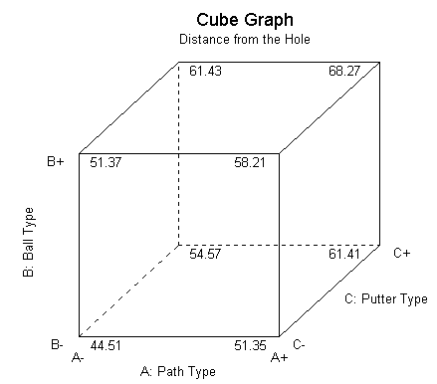
Due to his poor mechanics of putting and lack of skill, we truly believe his game doesn’t depend on those factors we had chosen. However, many interesting aspects of his game were revealed. From the residual and run plot of figure 8, one can see many data start to close up indicating his learning process during the putting experiment.

Figure 8. The residuals and run sequence order for the beginner’s experiments

Intermediate Player (25 handicap)
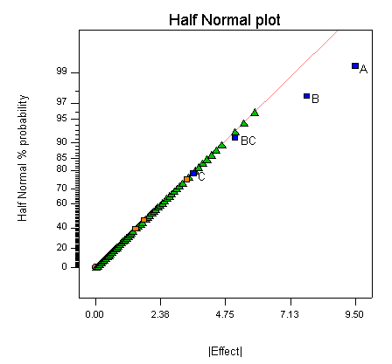
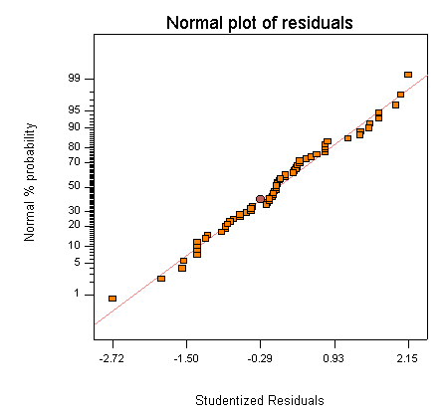
More than 50 percent of players are distributed between a 20 and 36 handicap according to the spectrum shown in Figure 6. The second player had 25 handicap which is close to the average handicap of all golfers in the world.

Figure 9. The half-normal plot and the normal probability plot for the intermediate player’s experiment
.

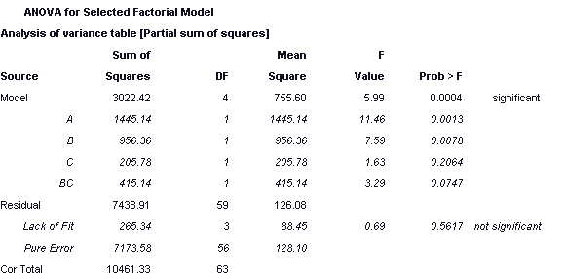
Table 1. Analysis of variance for the intermediate player.

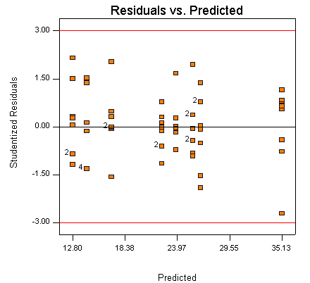
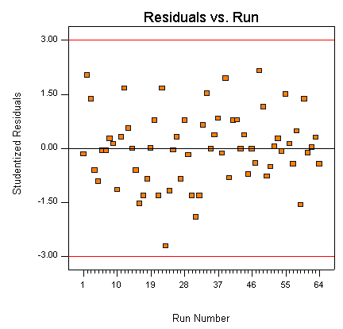
From the half-normal plot in Figure 9, two factors, A and B, were strongly involved in his game. Also interaction between B and C, the type of ball and putter seems to have some effect on the results. Due to this interaction and the hierarchy principle, we include the factor C in the model. There is no violation in residuals vs. predicted value plot in Figure 10. Unlike the beginner, he didn’t show any learning process to minimize his error during the putting experiment.

Figure 10. The residual vs. predicted value and run orders for the immediate player
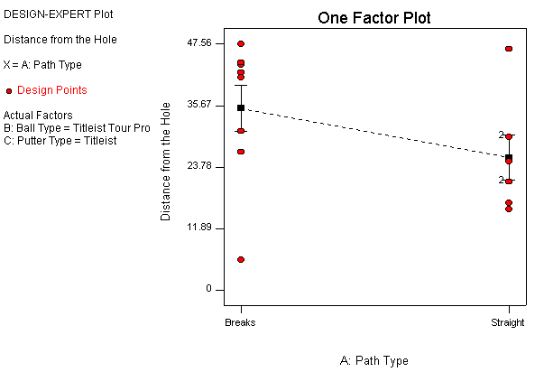
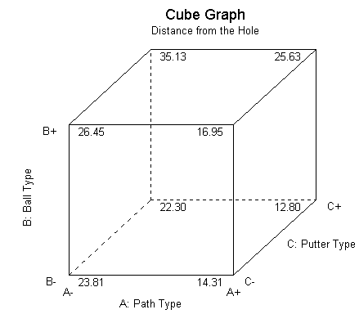
The analysis in Figure 11 shows he had a problem in reading the green. He putted better at the straight putt than he did on the breaking putt. There is also an interaction between ball and putter, which is quite interesting and shows that the milled face putter leads to different performance with different kinds of balls but the inserted face putter is less sensitive.
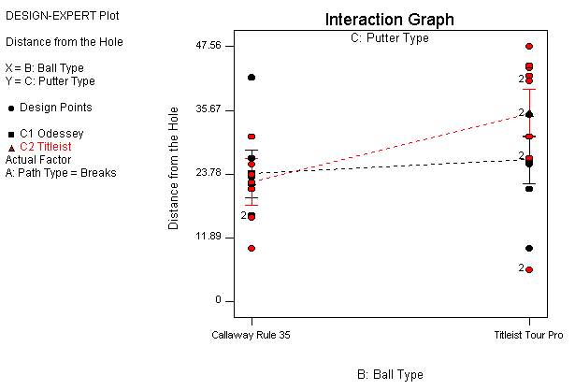

Figure 11. Experimental results for intermediate player

Advanced Player (9 handicap)
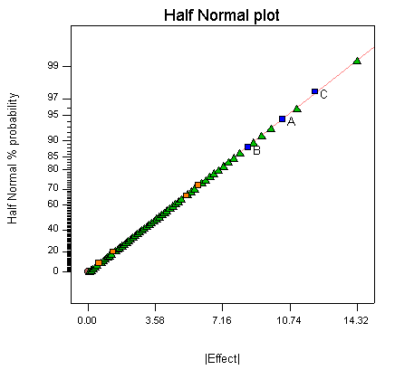
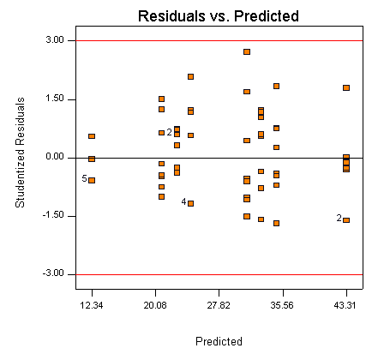
The third player we chose was the most exposed to the game, most enthusiastic and dedicated to improving his game in some degree. The analysis of variances also revealed interesting results. There were ambiguities of factor influences and it seems none of the factors are significant. There were violations in the assumption of homogeneity of variances according to the half-normal plot and residuals plot in Figure 12.

Figure 12. The half-normal plot and the normal probability plot before the transformation

But it is clearly resolved by applying a variance-stabilization transformation. The observations have some degree of the Poisson distribution, therefore the square root transformation was used as shown in Figure 13.
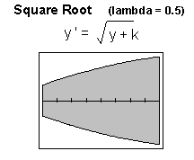

Figure 13. The square root transformation and the residual vs. predicted value plot

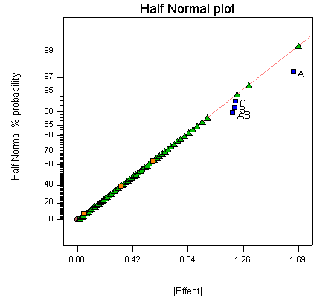
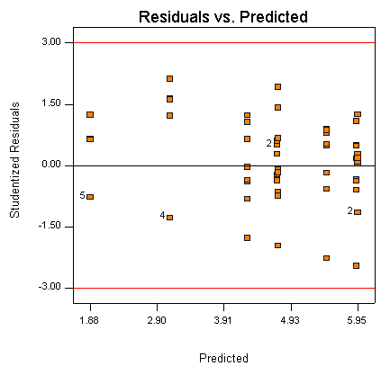
After the transformation, the significant factors became obvious from the half normal plot and there is no particular violation in the equal variance in Figure 14.

Figure 14. Half normal plot and residual vs. predicted plot for the advanced player

Factor A has the highest average effect mean among other factors. But still three main effects and one interaction turned out to be significant factors in Table 2.

Table 2. The analysis of variance for the advanced player
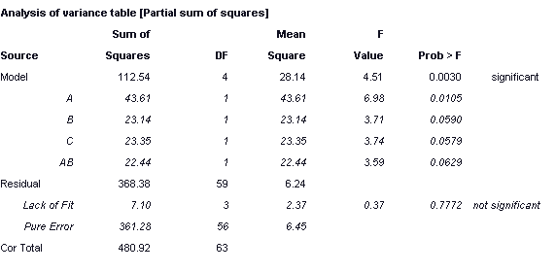

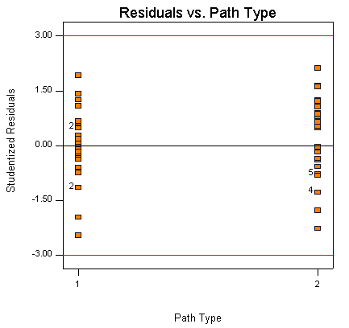
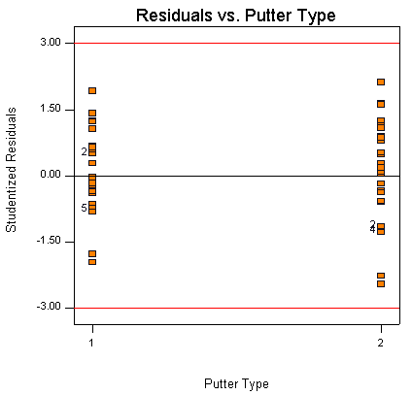
The equal variances can be shown in the residuals vs. main factor plots in Fig. 15.

Figure 15. Residual vs. path type and residual vs. putter type for the advanced player

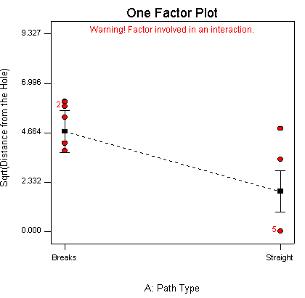
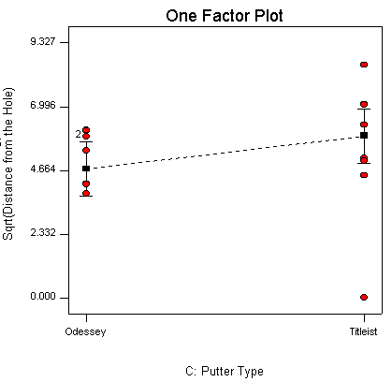
It is obvious that this particular player made a lot of good putts at straight putting compared to break putting condition, which is also observed in the intermediate players in Fig. 16. There was also a small average main effect of putter type, not very significant compared to factor A, putting path.

Figure 16. One factor plots for path type and putter type for the advanced player

There is also an interaction between ball type, factor B and putting path, factor A and it requires further detailed study and experimentation to determine the true meaning of the interaction in Fig.17.
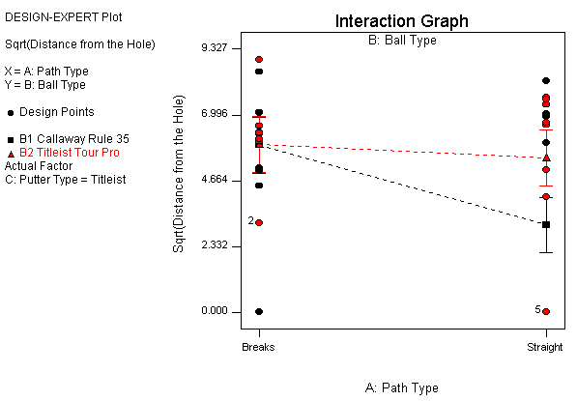

Figure 17. Interaction plot between path type and ball type for the advanced player

We can say that overall the advanced player showed good green reading skill and speed control as in Figure 18 and interestingly enough, he also showed, just like the beginner, that he learned and adapted himself to minimize his error during the experiment, which is clearly shown in the residuals vs. run plot in Figure18.
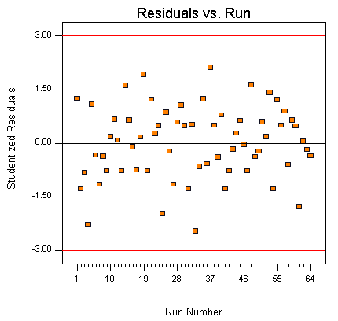
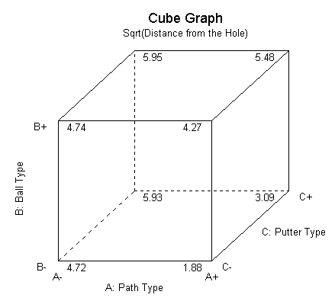

Figure 18. Cube graph and residual vs. run order for the advanced player

Conclusions

We conducted putting experiments for three different leveled players in order to understand and analyze their games. What is the most important factor that each player should be aware of during putting? Is it quite an individual factor that applies for a certain player or could it be a common problem for many players? We conceptually know some answers with experience. However it may not be good enough or can be more solidified and verified with scientific design and analysis of experiments (DOE) [2]. Many pieces of fact-revealing and educational information were collected during the process.
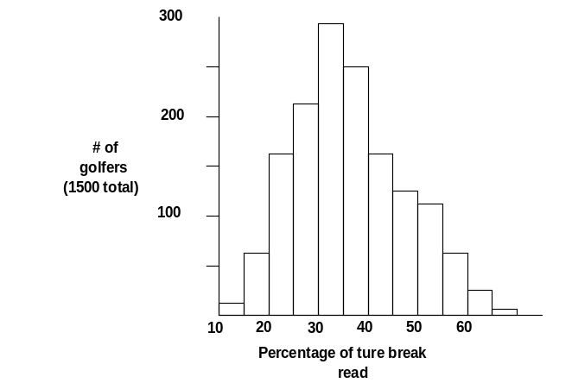For the beginner, he needed to learn the basics of putting mechanisms to improve his game. However, the green-reading skill was the most important factor for players other than the beginner. Another survey [3] also shows the difficulty of green-reading skill and only about one third of the true amount of break is read in their putts as in Figure19.

Figure 19. Percentage of true break read. [3]

Although our results can be applied for the participants in our test, the basic concepts of DOE techniques can be successfully employed for the detailed analysis of the putting game. The summarized effects of each player are tabulated in Table 3. It is hard to interpret the scientific meaning of the interactions of main effects without further study and collection of data.

Table. 3. The significant factors in order for each player.

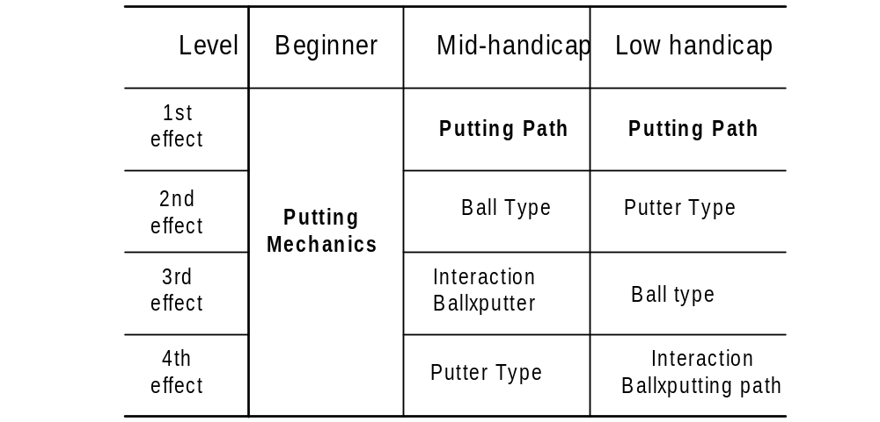

Reference

[1] D. C. Montgomery. “Design and Analysis of Experiments”, 5th edition, Wiley, New York, 2000
[2] D. Pelz, “Dave Pelz’s Short Game Bible”,Doubleday, New York, 2000
[3] D. Pelz, “Dave Pelz’s Putting Bible”,Doubleday, New York, 2000

